17th International Conference on Urban Drainage, June 6-11, 2027, Ningbo, China

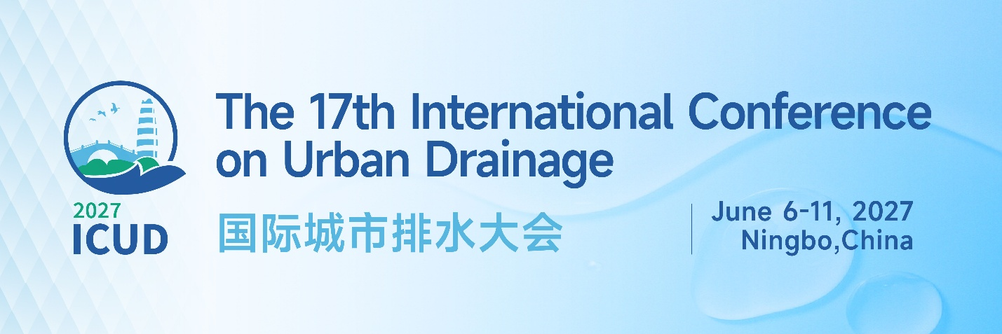
First Announcement

About the Conference

The International Conference on Urban Drainage (ICUD), supported by the IAHR/IWA Joint Committee on Urban Drainage, has been held sixteen times worldwide since its inauguration in 1978. The conference convenes academic scientists, researchers, and practitioners to exchange findings and experience across all aspects of urban drainage. It also provides an interdisciplinary forum to present and discuss recent developments, emerging trends, and practical challenges in the field. The 17th International Conference on Urban Drainage (ICUD 2027) will be held in Ningbo, China, from June 6 to 11, 2027. This marks the first time in ICUD’s nearly 50-year history that the conference is hosted in China, reflecting the growing contributions of Chinese researchers and practitioners to international collaboration.

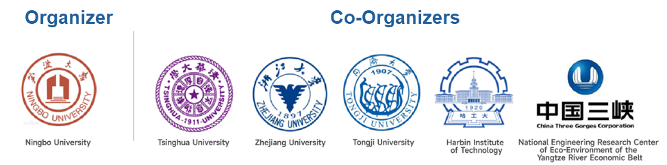
Venue
Ningbo, a vibrant city with a population of 10 million, is located on the east coast of China, in the heart of the Yangtze River Delta. The city is connected to Shanghai by Hangzhou Bay Bridge - one of the longest sea-crossing bridges in the world. It offers more than 300 flights daily from/to domestic and international destinations, as well as more than 150 high-speed train services per day linking to most major cities in China.

The conference will be held at the five‑star Pan Pacific Ningbo hotel, and its website is www.panpacific.com/en.

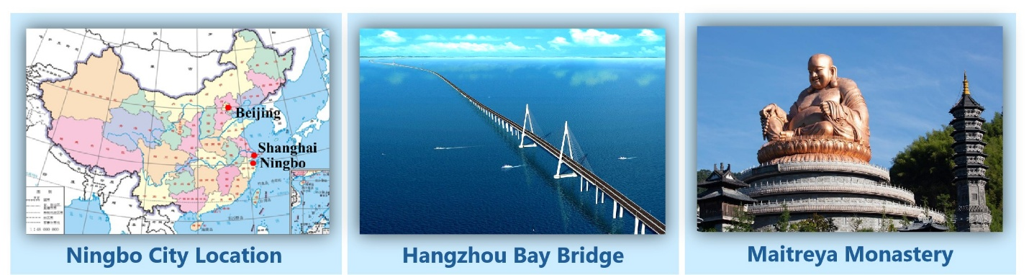
For more information about Ningbo, please visit the official government website https://www.ningbo.gov.cn/col/col1229172783/index.html
and the Ningbo touring website: http://www.cityofningbo.com.cn/
Call For Papers, Special Sessions, & Posters

The conference will cover various areas of urban drainage. Suggested topics include but are not limited to:
- Urban Hydrological Processes
- Urban Flooding Modeling and Mitigation
- Climate Change Adaptation and Resilient Infrastructure
- Blue-Green Infrastructure and Nature-based Solutions
- Sewer Infrastructure Renewal & Asset Management
- Integrated Urban Water Management
- Urban Water Ecology and Environment
- Sustainable Urban Drainage in Low Income and Developing Regions
- Citizen Science and Community Engagement in Urban Drainage
- Emerging contaminants
- Circular Water System
- AI, Machine Learning and Digital Twins
- Others

Call for organizing special sessions
- Proposals for special sessions are invited. Submit proposals by July 1, 2026 to ICUD@nbu.edu.cn.

Early Bird Registration Fee
 | High income country | Low income country
IAHR/IWA | € 550 | € 400
Non IAHR/IWA | € 600 | € 450
Student | € 300 | € 250

Poul Harremoës Award
- Researchers aged 35 or under are eligible to apply for the award.
- Indicate your interest in the award when submitting your abstract.
- Details on the nomination process are available on the conference website.
Important Dates

Apr. 1, 2026: Abstract Submission System Opens
Dec. 1, 2026: Abstract Submission Deadline
Feb. 1, 2027: Notification of Acceptance
Feb. 1, 2027: Online Registration Opens
Mar. 1, 2027: Revised Abstracts Due
Apr. 1, 2027: Early Bird Registration Closes
Jun. 6 - 11, 2027: ICUD Conference

Conference Website

Download Flyer
Conference Committees

Conference Chairs


Advisory Committee
- BUTLER, David (Univ. of Exeter)
- HUANG, Guohe (Univ. of Regina)
- McBEAN, Edward (Univ. of Guelph)
- QU, Jiuhui (Tsinghua Univ.)
- REN, Nanqi (Harbin Inst. of Tech.)
- TANG, Hongwu (South China Univ. of Tech.)
- WANG, Chao (Hohai Univ.)
- WANG, Fuming (Sun Yat-sen Univ.)
- XIA, Jun (Wuhan Univ.)
- XU, Weilin (Sichuan Univ.)
- XU, Zuxin (Tongji Univ.)
- YANG, Zhifeng (Beijing Norm. Univ.)
- ZHANG, Jianyun (NHRI)

Scientific Committee
Chairs
- LEE, Joseph H.W. (Macau Univ. of Sci. and Tech.)
- YUAN, Zhiguo (Hong Kong City Univ.)
Members
BOMBARDELLI, Fabian (Univ. Calif., Davis)  CARADOT, Nicolas (KWB Berlin)  CHANG, Tsang-Jung (Taiwan Univ.)  CHAI, Hongxiang (Chongqing Univ.)  CHERQUI, Frédéric (INSA Lyon)  CLEMENS, Francois H.L.R. (SkillsInMotion)  CHO, Hiroshi (Kumamoto Univ.)  DJORDJEVIC, Slobodan (Univ. of Exeter)  ETTEMA, Robert (Colorado State Univ.)  Fletcher, Tim (Univ. of Melbourne)  FuRuMai, Hiroaki (Univ. of Tokyo)  GHIDAOUI, Mohamed (HK Univ. Sci. & Tech.)  GUO, Qizhong (Rutgers Univ.)  HATHAWAY, Jon (Univ. of Tennessee)  HE, Qiang (Chongqing Univ.)  HODGES, Ben (Univ. of Texas Austin)  Huang, Guangwei (Sophia Univ.)  JIANG, Feng (Sun Yat-sen Univ.)  KAPELAN, Zoran (TU Delft)  KARNEY, Bryan (Univ. of Toronto)  Kawaike, Kenji (Kyoto. Univ.)  KLEIDORFER, Manfred (Univ. of Innsbruck)  LANGEVELD, Jeroen (TU Delft)  LAW, Adrian W. K. (Nanyang Tech. Univ.)  LI, Junqi (Beijing Univ. of Civ. Eng. & Arch.)  LI, Yongping (Beijing Normal Univ.)  LU, Jinsuo (Xi’an Univ. of Archi. Tech.)  Luo, Pingping (Chang’an Univ.)  McCARTHY, David (Univ. of Guelph) | MuGume, Seith (Makerere Univ.)  Okedi, John (Univ. of Cape Town)  Peng, Jing (IAHR/ China IWHR)  Qian, Shangtuo (Hohai Univ.)  Rauch, Wolfgang (Innsbruck Univ.)  SCHELLART, Alma (Univ. of Sheffield)  SHI, Baiqian (Monash Univ.)  Spraakman, Sylvie (City of Vancouver)  Stovin, Virginia (Univ. of Sheffield)  TAIT, Simon (Univ. of Sheffield)  TSCHEIKNER-GRATL, Franz (NTNU)  VALEO, Caterina (Univ. of Victoria)  VAN DUIN, Bert (City of Calgary)  VAN ZYL, Kobus (Univ. of Auckland)  VANROLLEGHEM, Peter (Laval Univ.)  VASCONCELOS, Jose (Auburn Univ.)  VOLLERTSEN, Jes (Aalborg Univ.)  ViKLander, Maria (Luleå Univ. of Tech.)  WANG, Peifang (Hohai Univ.)  WANG, Xiaochang (Xi’an Univ. of Archi. Tech.)  WU, Shiqiang (Nanjing Hydr. Res. Inst.)  XIA, Xinghui (Beijing Normal Univ.)  Xu, Yueping (Zhejiang Univ.)  YI, Yujun (Beijing Norm. Univ.)  Zhang, Wenming (Univ. of Alberta)  ZHAO, Yaqian (Xi’an Univ. of Tech.)  ZHENG, Chunmiao (South China Univ. Tech.)  ZHENG, Feifei (Zhejiang Univ.)  ZHOU, Ling (Hohai Univ.)
Sponsorship and Exhibition Opportunities

Sponsorship opportunities are available at Platinum, Gold, Silver, and Bronze levels. Sponsors can receive a range of promotional benefits and visibility at the conference.
Official Website & Contact

Website: https://www.icud2027.cn/
Email: ICUD@nbu.edu.cn
Phone: +86-574-87605922

